Documentation of Non-CO2 Greenhouse Gas Modeling in ObjECTS MiniCAM
Page Kyle
September 16, 2008

This document identifies all data sources used and all calculations performed in mapping emissions from inventories to corresponding technologies in MiniCAM.

Broad Overview
The files are available on the shared drive at:

RCP Scenario\MiniCAM

The set of xml input files used is a modified version of the CCTP FY08 Reference case. It differs from the CCTP in that it (a) has non-CO2 greenhouse gases, (b) has transportation sectors worldwide broken out by mode, namely air, rail, road, pipeline, domestic ship, and international ship, and (c) uses old MiniCAM regional designations for the energy system. However, the emissions coefficients are calculated using the IMAGE MiniCAM regions, as these correspond well to the EDGAR regions; a list of the IMAGE MiniCAM regions can be found on the shared drive at:

IEA Database\2005 Calibration (most recent)\Documentation\MiniCAM_IEA_IMAGE_regions.xls

The energy system and AgLU system input files are made separately, and are addressed separately in this document.

Energy System
Non-CO2 gases in the energy system are calculated according to the following method:
- Emissions data are linked from a primary source, either the EPA, EDGAR 2000, the RETRO database, Lex Bouwman’s NH3 dataset, or EMF-21.
- A driver is assumed (fuel consumption or service output), and emissions are mapped to MiniCAM technologies, with disaggregation (where necessary) generally informed by known drivers and observed emissions coefficients.
- Emissions are adjusted to match “expert” estimates of emissions by region and RCP emissions category.
- Parameters for GDP-based control functions are set, or marginal abatement curve information is collected from EMF-21.
- Uncontrolled emissions coefficients are calculated as the amount of emissions divided by the corresponding drivers in the base year (2000; using IMAGE MiniCAM regions), influenced also by the assumptions of the control function.
- These emissions coefficients are input to the model, and the model is run using energy consumption estimates from the old MiniCAM regions (in 1990 and 2005).

The resulting model output emissions do not match the 2000 input data because of (a) nonlinear drivers between 1990 and 2000 and 2005 and (b) different region designations. To get the actual 2000 emissions, the Input Data \ Aggregated Energy GHG Data.xls workbook has a worksheet called “[gas]_2000” for each gas that has a table at the top with the 2000 emissions mapped to all relevant MiniCAM technologies.

Mapping of emissions to MiniCAM technologies
Data Sources
Data sources are listed for each gas in the energy system in the table below:

CH4 | EDGAR 2000
N2O | EDGAR 2000
NOx | EDGAR 2000, adjusted to van Aardenne estimates*
CO | EDGAR 2000, adjusted to van Aardenne estimates*
SO2 | EDGAR 2000, adjusted to Smith estimates
NMVOC | EDGAR 2000, adjusted to van Aardenne estimates*
NH3 | EDGAR 1990
BC | Bond and Street 2003 (for 1990 only)
OC | Bond and Street 2003 (for 1990 only)
HGWP | EMF 21 / Emissions 1990-2020 / Appendix D_TA_HighGWP.xls
shipping | Eyring et al 2008 (or 2005)
* See Appendix

Data was taken from EDGAR for all but the HGWP’s, BC and OC. The first step was disaggregating China and Korea, which are in the same region in the EDGAR database; the fractional allocations were based on the relative share of the drivers assumed for each region. That is, for disaggregating fossil fuel-related emissions from the industrial sectors of China and Korea, the total fossil energy consumption (gas + coal + non-feedstock oil) of each region was used (China gets 88% of the emissions; Korea the remaining 12%).

Mapping from EDGAR to MiniCAM
Emissions of all energy-consuming technologies are assumed to have input drivers (these scale with energy consumption). Industrial processes and urban processes have output drivers, but because these are “fake” technologies and do not consume an actual input or become more or less efficient, the driver is irrelevant (they are only in the model to produce non-CO2 emissions).

Data in the EDGAR database that corresponded one-to-one with MiniCAM technologies (with no further disaggregation required) were mapped accordingly; these generally consisted of the energy production sectors (regional coal, oil, and gas), aviation, and sometimes industrial processes and landfills. Most of the EDGAR categories did need to be disaggregated or aggregated, however; this was generally done in the spreadsheets in the order which the categories appear in the EDGAR database. The following is a list of EDGAR categories:

B10-INDUSTRY | I10: IRO: IRON&STEEL
B20-POWER GENERATION | I20: NFE: NON-FERRO
B30-CHARCOAL PRODUCTION | I30: CHE: CHEMICALS
B40-RCO: RESIDENTIAL | I40: BUILDING MATERIALS
B51-ROAD TRANSPORT (ETH.) | I50-PAP: PULP & PAPER
F10-INDUSTRIAL SECTOR | I60: FOO: FOOD (BEER&WINE)
F20-POWER GENERATION | I70: SOLVENT USE
F30-OTS (ALL) | I90: MIS: IND. MISCELLANEOUS
F40-RCO SECTOR(RES+COM+OTH) | W10-LANDFILLS (INCL. CH4 REC.)
F51-ROAD TRANSP.(INCL. EVA) | W20-WASTEWATER TREATMENT(+REC)
F54-TRANS. LAND NON-ROAD | W30-HUMAN WASTEWATER DISPOSAL
F57-AIR (ALL) | W40-WASTE INCINER.(NON-ENERGY)
F58-INTERN. SHIPPING | W50-MISC. WASTE HANDLING
F70-COAL PROD.(+ CH4 REC.)
F80-OIL PRODUCTION
F81 OIL PROD. (PROCESSES)
F83 OIL HANDLING (TANKERS)
F84 OIL PROD.: GAS FLARING
F90-GAS PRODUCTION
Note: B stands for emissions from biomass fuels; F from fossil fuels; I from industrial processes, and W from waste.

B10, B20, B30: Charcoal emissions are counted as industrial sector emissions. Biomass emissions from industry and the electric power sector were added together, and then disaggregated according to the energy shares of each in MiniCAM. The reason for this is that the definitions between industry and electricity sector are a bit blurred for biomass, and in the IEA energy balances, the definition shifts from year-to-year. Where the energy analysts draw the lines around paper mills and their corresponding waste biomass power plants determines much of what biomass is considered “industry” versus “electricity” sector.

B40: Biomass in the buildings sector was disaggregated between “delivered” (commercial) and “traditional” biomass according to the energy shares of each. For the developed world, this was 100% delivered biomass, and for the developing world, the disaggregation (as for the energy input data) assumes that the IEA category “Primary solid biomass” consumed by the Residential sector is “traditional biomass.”

B51: Biomass (ethanol) in the transportation sector was added to the technology for all refined liquids in MiniCAM, as there is no separate technology for vehicles consuming biofuels. In MiniCAM, the fuels are blended before being consumed by the transportation sector.

F10, F30: For disaggregation of fossil emissions from the industrial and transformation sector (note that these are both accounted in the “industry” sector in MiniCAM) into the actual fuels (coal, gas, oil), the first step was to calculate the energy shares of each fuel. Note that this method is repeated for F20 and F40. However, because each of these fuels has different emissions coefficients, emissions are not assigned purely on the basis of the energy shares. Emissions shares are calculated based on the emissions shares by fuel for this category in the US EPA’s submission to the UNFCCC for 2005. The energy shares of each fuel are multiplied by a predicted:observed adjustment factor for each fuel, and then these adjusted shares are normalized to 100% to serve as the actual shares.

F20: Emissions are disaggregated as for F10 and F30; the energy shares from coal, gas, and oil power plants in each regions are adjusted by the actual emissions from each fuel in the US. This adjustment had the effect of, for example, increasing the assumed share of NOx emissions from coal power plants with respect to gas power plants, as the coal power plants have a higher emissions coefficient.

F40: Emissions are disaggregated as for F10 and F30.

F51: Road transport was disaggregated between natural gas and refined liquids consumption by this sector in each region; because the gas consumption in each region was so low, no separate emissions factors were used. In fact, it isn’t clear whether the gas consumption was even taken into consideration in developing the emissions databases, but emissions were nevertheless assigned so that we don’t have any emissions-free technologies in the model. In some scenarios gas does become important for road transport in the future. It should be noted here that while “pipeline” is a subsector of the transportation sector in MiniCAM, emissions associated with pipeline transport are actually found in the regional natural gas sector of each region. It wasn’t possible or desirable to assign emissions to the pipelines (as separate from the energy storage and production facilities).

F54: Non-road land transport was disaggregated by fuel shares among coal-fueled rail, liquid-fueled rail, coal-fueled domestic ships, and liquid-fueled domestic ships.

F58: International shipping emissions were taken from Eyring et al (2008), where possible, and from Eyring et al (2005) as a second option. For N2O, EDGAR was used, as this gas was not in either Eyring database. The emissions were assigned to regions on the basis of the IEA fuel shares for each region.

IXX: In general, industrial process emissions were aggregated together and mapped to “Other industrial processes” in MiniCAM, as this is a catch-all category for most industrial processes. I70 (Solvent use) was mapped to solvents, and in N2O, the I30 (Chemicals) category was separated into adipic and nitric acid, which each get a technology in MiniCAM; the disaggregation follows the EDGAR 1990 data (as the two industrial processes were disaggregated in that dataset).

W10, W40, W50: mapped to landfills
W20, W30: mapped to wastewater treatment

Side Note: SO2
Because SO2’s climate effects are regional (as opposed to global), MAGICC requires that the emissions be sourced to one of three world regions. However, the line between two of the regions splits the Former Soviet Union, so we actually have four types of SO2, depending on the region of origin. The only thing this changes in the model is the name of the gas, but users should be aware of it; the names follow the designations mapped below:

MiniCAM region | SO2 name
USA | SO2_1
Canada | SO2_1
Western Europe | SO2_1
Japan | SO2_2
Australia_NZ | SO2_3
Former Soviet Union | SO2_4
China | SO2_2
Middle East | SO2_3
Africa | SO2_3
Latin America | SO2_3
Southeast Asia | SO2_2
Eastern Europe | SO2_1
Korea | SO2_2
India | SO2_2

Harmonization
The final step is an adjustment to harmonize our input data to “expert” databases. In summary, we harmonize to agreed-upon estimates for emissions, but those estimates don’t have adequate detail to use as the basis for the mapping. The three databases from John van Aardenne (NOx, CO, and NMVOC) have emissions disaggregated to the following relevant RCP categories: ENE (electricity and energy production), TRA (transportation excluding aviation and international shipping), IND (industry energy-use and industrial processes), DOM (buildings sector), SLV (solvents), and WST (waste).

The adjustment follows several steps:
- Data from expert database is aggregated by MiniCAM region and RCP emission category
- Emission data from MiniCAM technologies is aggregated according to RCP emission category
- A scaling factor is computed as the (expert / MiniCAM) estimate
- This factor is applied to the emissions estimates for all corresponding technologies in MiniCAM.
For SO2 (Steve Smith’s dataset), some additional scaling was involved, because the dataset was only partially disaggregated by RCP category. For five regions, the disaggregation of emissions was only given in terms of fuel consumption; for these regions, no RCP-category scaling was used. Rather, fuel multipliers for each fuel were computed in similar fashion to the method outlined above. For a sixth region, Latin America, some countries had emissions split by RCP category and others had emissions split by fuel type, so there was no way to adjust the EDGAR estimates to the expert dataset.

High-GWP gases
Because no dataset (either from an expert or from EDGAR) is available, the EMF-21 study is used here. Emissions are read in for 1990, 2005, and 2020, along with MAC curves from the EMF study. Some disaggregation was required; the mapping followed the scheme below:
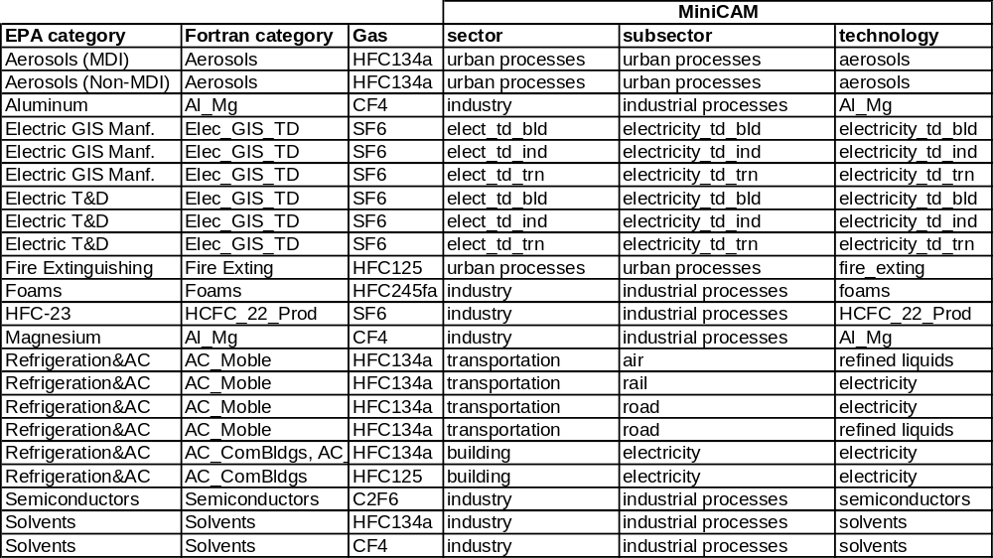

In summary, the EPA categories were first mapped to Fortran MiniCAM categories; the calculations for disaggregating Refrigeration&AC were done back in 2001, and have been preserved as no direct links to the source data/assumptions have been preserved. The Fortran MiniCAM calculations disaggregated Refrigeration&AC emissions between mobile and stationary sources, for instance.

The emissions from the Fortran categories were then assigned to corresponding MiniCAM technologies, and disaggregated according to output shares. The high-GWP gases are all assumed to be driven by outout, not input; that is, if cars become more fuel-efficient in the future, it will reduce fuel consumption but not refrigerant emissions. Where a single Fortran category applies to multiple MiniCAM technologies, disaggregation takes place on the basis of output. “Output” of all urban processes is assumed to grow with population, and output of all industrial processes grows with output of the industry sector for each region.

BC and OC
Because no dataset (either from an expert or from EDGAR) for 2000 is available, the data used is from 1990, and 1990 drivers are used in calculating coefficients. The designations in Tami Bond’s data match the MiniCAM categories pretty well; the only disaggregation required was separating commercial from traditional biomass emissions in the regions where the designation applies. While there are 2000 estimates in Eyring et al. (2008) for BC and OC emissions from global shipping, these aren’t used at present, to keep the representation simple (all using the same base year). When we get 2000 data for BC and OC, the Eyring estimate will be used.

GDP Control Functions
The functional form of the GDP control functions in MiniCAM is complicated and this will only briefly go over it. In summary, there are seven relevant input parameters: one from the data (input-emissions), and six co-dependent user-set parameters. The parameters basically determine how much emissions each region is controlling for each technology in the base years, and how much it will control going forward. Because the GDP control function would be redundant with a MAC curve (they are separate functions that get multiplied), only one is used for each technology/gas. MAC curves tend to be used for GHG’s (CH4, N2O, and high-GWP’s) and GDP-control functions are used for pollutant gases, but really the distinction is drawn by data availability. Where the EPA published a MAC curve for EMF-21, we use the MAC curve and no GDP control function. Where we don’t have that data, we use a GDP control function. In reality, even the GHG non-pollutant gases might be controlled by practices designed to limit pollutants, as strategies to reduce NOx will reduce N2O, for example.

In any case, the GDP control function assumes logistic controls approaching a defined “max-control” as GDP increases. The parameters are as follows:

tag name | function
input-emissions | the amount of emissions in the base year
max-control | the maximum percentage of emissions that can be controlled
gdp-mid-control | the per-capita GDP (ppp) at which half of the possible controls are in place
gdp-control-range | the range of GDP between 10% and 90% of max-control
tech-diffusion | the rate at which gdp-mid-control decreases over time
uncontrolled-emiss-coef | the emissions coefficient (emissions / driver) if no controls were in place
final-emiss-coef | the emissions coefficient at max-control

The values of these parameters are generally set so that (a) the uncontrolled-emiss-coef is similar for the same technology across regions, (b) the 1990 predicted model emissions match actual emissions from inventories, where applicable, (c) the gdp-control-range is the same fraction of the gdp-mid-control for a given technology across regions, and (d) the final-emiss-coef’s for a given technology generally converge across regions. These are the goals that we aim for—not necessarily what’s there!

The figure below demonstrates the principle of emissions controls; the three curves all have the same gdp-mid-control, but differ in the gdp-control-range and the max-control. Note that the figure does not take tech-diffusion into account; for criteria pollutants, this would have the effect of making all of the curves steeper assuming GDP increases over time (i.e. more controls at lower GDP levels).

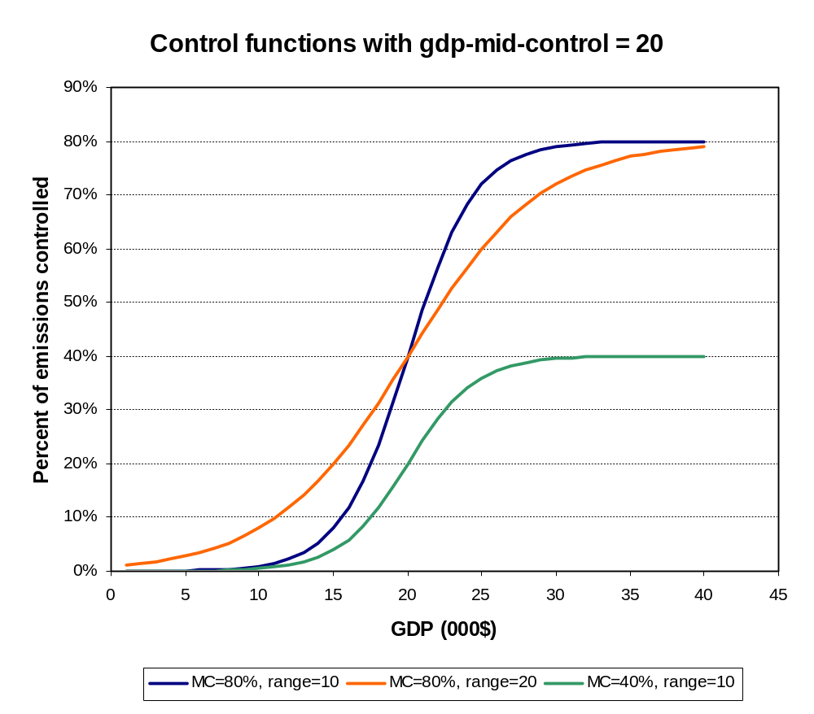

Tech-diffusion is constant for criteria pollutants across regions and technologies; the effect is that gdp-mid-control is assumed to decrease at 0.5% per year, corresponding to emissions reduction technologies becoming less expensive over time. Uncontrolled-emiss-coef’s for new technologies (e.g. hydrogen production, integrated gasification combined cycle (IGCC)) are based, where possible, on literature estimates, but for many of these we are using place-holder (though low) values at present. This may be adequate as a long-term solution—in addition to not being known, it is generally thought that emerging energy technologies such as IGCC, coal-to-liquids and coal-chemical hydrogen production will not generate much in the way of non-CO2 emissions, because the pollutants have to be scrubbed before the chemical processes can take place. In any case, the bottom line is that every technology that might ever come in and produce emissions is assigned an emissions coefficient. These are based on the literature where possible. Future emissions from all technologies are controlled by either a GDP-based control function, or by a MAC curve; the latter only applies in the case of a carbon price.

Agriculture and Land-Use System
Non-CO2 gases in AgLU are split into three categories, each of which gets its own xml input file to MiniCAM: the agriculture sector (crops only), livestock, and unmanaged land (emissions from open fires not on agricultural lands). The emissions sources and disaggregation techniques vary somewhat between the three categories; this is addressed in detail below. For the most part, they follow the same method as the energy system emissions, but the following changes should be noted:
- GDP control functions are only used for agricultural waste burning; all other emissions are assumed to be unresponsive to GDP. MACs are only used in the livestock sector for methane abatement, so climate policy does not have much leverage on emissions from this sector either.
- The expert datasets (from van Aardenne) have some inconsistencies for ag waste burning emissions; in regions where the inconsistencies were real bad, the expert datasets are not used.
- All emissions from agricultural waste burning are given the “_AWB” suffix, whereas all emissions from both the livestock and agricultural sectors that are not from ag waste burning are given the “_AGR” suffix. This is necessary because otherwise two RCP emissions categories would get merged in a single MiniCAM technology. It doesn’t matter for anything in the model but users ought to be aware of it. No other gases are tagged by their RCP emission category.
- Unmanaged land emissions are not input to the model by emissions coefficients; they are hard-wired as emissions, set equal in 1990 and 2005, in order to return the correct value for 2000. Because the drivers are endogenous (and squirrelly at present), this short-term solution might end up being a medium-term solution.
- I don’t have 2000 AgLU data, so the drivers are calculated from interpolated 1990-2005 data. This shouldn’t matter because there probably aren’t bow-shaped curves in the AgLU sector. This means that the AgLU emissions output from a model run should match the actual 2000 input data.

Agricultural and Livestock Sectors
The agricultural and livestock sector data is from the following sources:
CH4 | EDGAR 2000
N2O | EDGAR 2000
NOx | EDGAR 2000, adjusted to expert database*
CO | EDGAR 2000, adjusted to expert database*
NMVOC | EDGAR 2000, adjusted to expert database*
NH3 | Lex Bouwman, Neth. Env. Assmt. Agcy.
BC | Tami Bond (1990 only)
OC | Tami Bond (1990 only)
* See Appendix

As in the energy system, the first step to using the EDGAR data was to disaggregate China and Korea; this is done depending on the category. In general, China accounted for more than 95% of the emissions for all categories:

 | China | Korea | source
fertilizer use | 98% | 2% | Bouwman NH3 dataset
rice cultivation | 97% | 3% | Rice production (FAO)
enteric fermentation | 97% | 3% | Feed to livestock (FAO)
manure management | 97% | 3% | Feed to livestock (FAO)
agricultural waste burning | 98% | 2% | waste biomass production (calculated from FAO)
crop production | 98% | 2% | FAO
unmanaged manure | 98% | 2% | feed inputs to pastoral production, FAO

The next step was to assign the EDGAR categories to intermediate categories, that are then assigned to MiniCAM technologies on the basis of output shares. This is shown in the table below (pasted directly from the Aggregated Aglu GHG Data.xls workbook):

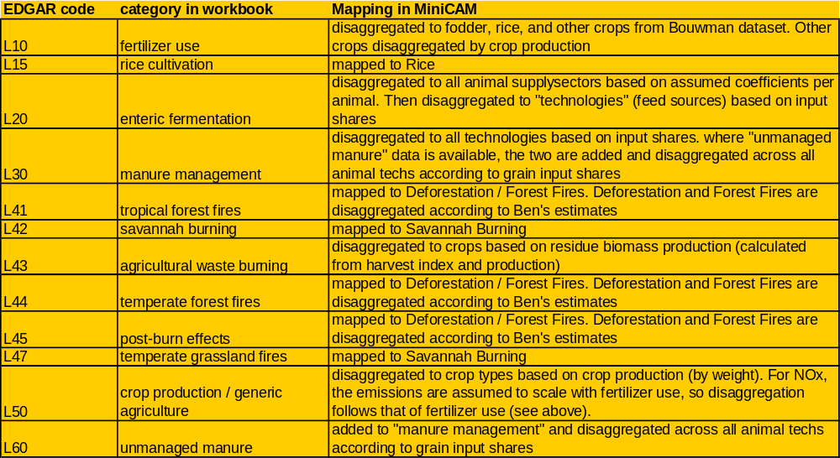
Note: The categories L41 to L47 are currently based on the RETRO database, so the mapping indicated in this table should be ignored.

In summary, crop output was used as the driver for emissions from crops (the alternative would have been land used). However, for disaggregating the base year emissions from the emissions categories to MiniCAM technologies, more nuanced approaches were generally used. For agricultural waste burning, the amount of residue biomass produced by each crop, in kt, was calculated from the crop output in kt (from FAO) divided by the harvest index of each crop (calculated by Jay Gregg). As well, for “crop production / generic agriculture,” the crop output in kt was used as the basis for emission disaggregation, rather than Gcal, because one of the crops (FiberCrop) is not represented in terms of Gcal.

Feed input was used as the driver for emissions from animals; it is assumed that ruminant emissions scale with the amount of feed consumed rather than the number of calories of beef/dairy produced. For CH4, a bottom-up calculation was used to assign the emissions to the different animal supplysectors in each region, because of the very different emissions profiles of the different animals. The disaggregation was based on the following table of CH4 emissions in kg per animal per year (source: IPCC,
http://www.ipcc-nggip.iges.or.jp/public/gp/bgp/4_1_CH4_Enteric_Fermentation.pdf ):

MiniCAM region | IPCC region | Dairy | Beef | Pork | Poultry | Sheep/Goat
USA | North America | 118 | 47 | 1.5 | 0 | 6.5
Canada | North America | 118 | 47 | 1.5 | 0 | 6.5
Western Europe | Western Europe | 100 | 48 | 1.5 | 0 | 6.5
Japan | Asia | 56 | 44 | 1 | 0 | 5
Australia_NZ | Oceania | 68 | 53 | 1.5 | 0 | 6.5
Former Soviet Union | Asia | 56 | 44 | 1 | 0 | 5
China | Asia | 56 | 44 | 1 | 0 | 5
Middle East | Africa and Middle East | 36 | 32 | 1 | 0 | 5
Africa | Africa and Middle East | 36 | 32 | 1 | 0 | 5
Latin America | Latin America | 57 | 49 | 1 | 0 | 5
Southeast Asia | Asia | 56 | 44 | 1 | 0 | 5
Eastern Europe | Eastern Europe | 81 | 56 | 1.5 | 0 | 6.5
Korea | Asia | 56 | 44 | 1 | 0 | 5
India | India | 46 | 25 | 1 | 0 | 5

These numbers were multiplied by animal stocks in each region to generate an estimate of the methane emissions share from each animal type. These bottom-up estimates were only used to scale the EDGAR emissions between the five animal types in each region; the emissions totals in the model are from EDGAR. The emissions were then disaggregated to technology (feed type) based on the caloric content of the feed (FAO data). Manure management emissions were assigned to all animal technologies purely on the basis of the caloric content of the feed input. The two sources of emissions (manure and enteric) were aggregated, as there is no reason to keep them separate for this project. MAC curves, which were separate for each of these in the EMF study, were aggregated based on the relative share of CH4 emissions (enteric versus manure-based) in each region. The result is that each region has a single MAC curve for each animal sector, and the dairy/beef curves have more abatement potential than other animals because they include the enteric fermentation abatement options.

For N2O and NH3, data on “unmanaged manure” was available. These “unmanaged” emissions were added to the “managed” (or confined) manure emissions and disaggregated to all animal technologies (in both the pastoral and mixed subsectors) according to grain input shares. This was originally done assigning unmanaged manure to pastoral subsectors, and managed manure to mixed subsectors, but the resulting emissions coefficients were too high for pastoral systems. It was clear that the EDGAR distinction between the two manure types does not match our criteria for the separation between mixed and pastoral systems. Pastoral systems still have higher emissions per unit output than mixed systems, but only because of lower efficiencies (Gcal of meat produced per Gcal of feed input).

Categories L41 through L47 are in the unmanaged land sector, and will be addressed later in this document. At present, EDGAR is not used as the source for these emissions.

The Bouwman NH3 dataset disaggregated emissions to a number of categories, shown in the table below (pasted directly from the Aggregated AgLU Input Data workbook):

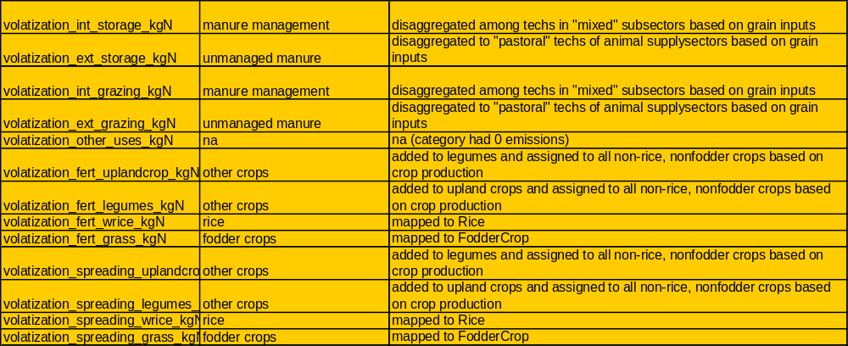

In summary, FodderCrop and Rice emissions from fertilizer and manure spreading were aggregated and assigned to the appropriate technologies. The upland crop and legume emissions were aggregated, and divided among the seven MiniCAM crops not otherwise specified in this dataset (Corn, Wheat, OilCrop, MiscCrop, SugarCrop, FiberCrop, and OtherGrain). All emissions associated with fertilizer use were assigned to crops in the same proportion. In other words, N2O from fertilizer use and NOx from generic (non-burning) agriculture were both assumed to follow the same crop disaggregations as NH3 in the Bouwman dataset.

GDP controls
As indicated above, a GDP-based emissions control function is used for all agricultural waste burning. In general, the parameters are chosen so that regions with high levels of ag waste burning per unit of crop output converge towards the totals in the developed world at some point in the future. The same exact parameters were applied to each gas, as the control “technology” is simply to stop burning. Unlike a power plant, where one might control SO2 but not CH4, for example, in the agricultural sector, reducing the amount of burning will simultaneously reduce all gas emissions. However, the control parameters chosen at present are quite modest, as even in the developed world there is a fair amount of agricultural waste burning.

Unmanaged Land Technologies
Modeling of unmanaged land technologies in MiniCAM is a work-in-progress. All that can be guaranteed is that the emissions in 2000 are correct, because (as stated above) the 2000 values are currently read in for both 1990 and 2005.

There are three unmanaged land technologies: savannah burning, deforestation, and forest fires. Savannah burning and forest fires are driven by unmanaged land, and deforestation is driven by land-use change. It is assumed that savannah burning doesn’t represent land conversion (from unmanaged to farmland), but rather burning that is the nature of the biome. The rules of unmanaged land technologies are as follows: the input to the unmanaged land technologies is unmanaged land, and the output of the unmanaged land technologies is land use change. So savannah burning and forest fires are driven by input, and deforestation is driven by output.

The data source used is the RETRO database, as put into MS Access by Sabrina Delgado-Arias. It uses the old MiniCAM regions, not the IMAGE MiniCAM regions. The gases from the RETRO database are mapped to MiniCAM non-CO2 GHG’s accordingly:

RETRO | MiniCAM
ACETONE | NMVOC
BC | BC
CH2O | NMVOC
CH3OH | NMVOC
CH4 | CH4
CO | CO
CO2 | CO2
ETHANE | NMVOC
ETHENE | NMVOC
H2 | na
N2O | N2O
NOX | NOx
OC | OC
PM2 | na
PROPANE | NMVOC
PROPENE | NMVOC
SO2 | SO2

It is assumed that the NMVOC gases listed in the RETRO database account for all NMVOC emissions (i.e. there are no other un-named ones). As shown, no attention is paid to H2 or PM2, and CO2 is also not used at any point in this exercise. The mapping to the unmanaged land technologies from RETRO to MiniCAM goes accordingly:

RETRO | MiniCAM
“forest” (consisting of all five IGBP forest classes and closed shrublands) | forest fires/deforestation
“wooded” (open shrublands and wooded savanna) | savannah burning
“grass” (savanna and grasslands) | savannah burning

Forest fires and deforestation are disaggregated in each region according to estimates put together by Ben Bond-Lamberty; in general, the method was to compare the amount of forest in each region with the estimated deforestation rate. The result was the following assumption:

MiniCAM region | Deforestation share
Former Soviet Union | 5%
Canada | 1%
USA | 5%
China | 20%
Australia_NZ | 5%
Southeast Asia | 90%
India | 50%
Latin America | 80%
Middle East | 90%
Western Europe | 90%
Eastern Europe | 90%
Japan | 95%
Korea | 95%
Africa | 50%

The remainder of deforestation/forest fire emissions were assigned to forest fires. Because SO2 is part of the dataset, this is named differently in the different regions (as in the energy system; see above).

NOTE: It was noticed that the forest fire emissions from Western Europe in the RETRO database are way off—the problem is not in the data aggregation but rather in the RETRO database itself. Emissions from Western Europe forest fires are slightly less than the US, and greater than Canada, in spite of having one tenth the forested area of either of these countries, and having net afforestation taking place. In the database, emissions from several countries are listed, but the Europe total is far greater than the sum of the listed countries. For this reason, the EDGAR database is used for Western Europe unmanaged land emissions (no other regions use EDGAR).

Final Notes
The regional designations are correct for what we want in this exercise. Everything uses the old MiniCAM regions, except for the calculations of the energy system emissions coefficients, which use the IMAGE MiniCAM regions. This corresponds well with the EDGAR dataset. The one inconsistency is that the AgLU input/output data used to compute coefficients is paired in several instances with EDGAR emissions data, so this will tend to under-estimate the emissions from our Southeast Asia region and over-estimate the emissions from our India region. The RETRO database uses the old MiniCAM regions and is not used to compute coefficients (only emissions) so this is fine. Ultimately we will probably want to switch everything over to IMAGE MiniCAM regions; this will require changes in the RETRO database, the AgLU inputs database, and in the input / energy / calibration folder, all xml files should be updated to those in the calibration_image_regions folder.

The next steps in non-CO2 modeling will probably involve doing research on emissions from future technologies, better parameterizing the control functions, and putting in any new data that comes along. Right now international shipping emissions are disaggregated according to the fuel shares in the IEA database, but the source for emissions from international shipping has higher energy consumption than the IEA database. Perhaps at some point a study will give regional break-outs of fuel consumption by international shipping.

Appendix: Note on Data Discrepancies
The places where our data sources diverge from what is in the text above are as follows:

Energy System
NOx: Using EDGAR for buildings sector (DOM) in Southeast Asia and India. As a reference point, both EDGAR and the expert dataset agree that CO in DOM is 61.7 for Africa, 20.6 for SE Asia, and 43.7 for India. For NOx they both agree that Africa is 1.82, and EDGAR has SE Asia at 0.91 and India at 2.32. The expert dataset has SE Asia at 0.25 and India at 0.09.

CO: The energy transformation sector in Australia_NZ, China, Southeast Asia, and Korea. The expert dataset had 0 for China, Southeast Asia, and Korea. This gas/category is actually worth more attention from the group--the expert dataset diverges from the EDGAR dataset pretty widely for almost all regions, and I don't know what's right. I might make an argument for just using EDGAR for this category (unless there's a good reason for the divergence).

NMVOC: Solvents (SLV) in SE Asia, Korea, and India. Expert dataset had 0's.

Agriculture and Land Use System
NOx: using EDGAR for Ag Waste Burning (AWB) emissions from Canada, Japan, Former Soviet Union, China, Southeast Asia, Eastern Europe, Korea, and India. Expert dataset had 0 for all of these regions, except for FSU, which was very small (e.g. 3% of the estimate for the Middle East). Japan and Eastern Europe had CO emissions, and Canada, China, and Eastern Europe had NMVOC emissions. This kind of discrepancy (e.g. fires that release one gas but not another) are obviously inconsistent.

CO: using EDGAR for AWB from Canada, Former Soviet Union, China, Southeast Asia, Korea and India.

NMVOC: using EDGAR for AWB from USA, Canada, Japan, Former Soviet Union, Southeast Asia, Korea and India. USA had 0 NMVOC emissions despite having both CO and NOx.

all gases: As explained above, Deforestation / Forest Fire emissions from the RETRO database are mistaken for Europe, so for Western Europe we are using EDGAR.

